Industry Use Cases for Kubernetes from Industry Experts

**Yesterday I attended a Webinar on Kubernetes - Industry Use Cases which was delivered by**[**Neeraj Bhatt**](https://www.linkedin.com/in/ACoAABV_s7kB7khyVUL98K0zLzu21iV17n5bk0E)**Sir(Senior Technical Engineer- OpenShift, Redhat ), [Vijit Kuntal](https://www.linkedin.com/in/ACoAABEUJjgB-YdiHVTPrq1kLL9qvlQAFJRkgGs) Sir(Consultant, Infosys Belgium) and [Rushil Sharma](https://www.linkedin.com/in/ACoAAAOvM1MBJ81lUbk7OiJmGSBK_zP-9LW3dyw) Sir( Customer Engineer Hybrid Cloud, Google).**

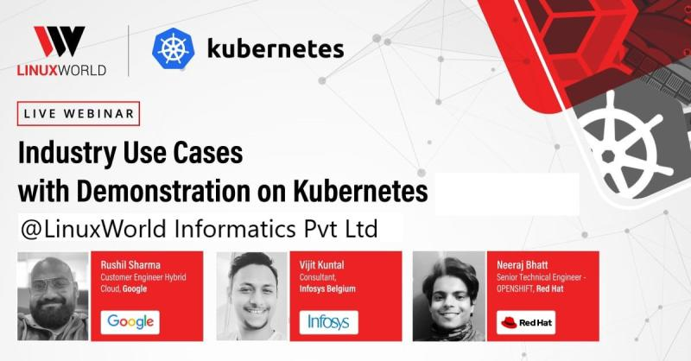

**Things which I learnt:**

**⭕CVS stands for concurrent version control system which is used for sharing the source code**

**⭕Difference between CVS & GIT is CVS work on concept file system whereas GIT work on the concept of modules & repo. Hence GIT is preferred more than CVS as it more convenient to use & is actually latest**

**⭕There is need of different environment in production because production is very critical for any country so we uses different environments for testing the code & also to check the quality of code. After it only we deploy it to production. Different environments is production are:**

**🔷️ engineering cluster: where we deploy the code which is not complete just for testing purpose**

**🔷️ SIT(system integration environment): where we deploy code when it's almost ready for production**

**⭕Global traffic manager is application level LB which work at layer 7 of OSI layer**

**⭕Namespace may be consider as box/environment where we deploy our app & its isolated from other ns**

**⭕Grafana is visualization tool used to graphically see what is the usage of h/w by the app**

**Some Glimps:**

